 | 7.2.13 Editors - 3D Viewport - Tool Shelf - Grease Pencil - Sculpt Mode
Table of content
Tool Shelf - Grease Pencil - Sculpt Mode 1
Annotate tools 1
Stabilize Stroke 1
Radius 1
Factor 2
Select Tools 2
Footer 2
Smooth brush 2
Thickness 2
Strength 2
Randomize 2
Grab 2
Push 2
Twist 2
Pinch 3
Clone 3

Tool Shelf - Grease Pencil - Sculpt Mode
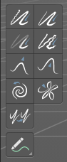
In Sculpt Mode you will mainly find brushes in the tool shelf.

The brushes settings are covered in the chapter 25.1.8 Editors - Properties Editor - Tools Tab - Grease Pencil Object.

Annotate tools
The annotate tools at the end of the list are explained in the chapter 7.1.1 Editors - 3D View - Tool Shelf - Object Mode. We won't cover this tools again here.

However, the active tool setting in Sculpt mode has an extra setting.

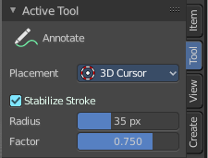
Stabilize Stroke
Helper to draw smooth and clean lines. Press Shift for an invert effect (even if this option is not active)

Radius and factor becomes visible when stabilize stroke is activated.

Radius
Stabilizer stroke radius. Minimum distance from last point before the stroke continues

Factor
Stabilizer stroke factor. Higher values gives a smoother stroke.

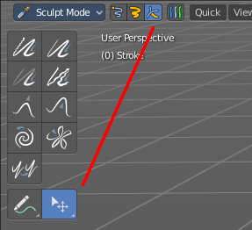
Select Tools
When you activate one of the mask modes then the select tool group appears. It is explained in the chapter 7.1.1 Editors - 3D View - Tool Shelf - Object Mode. We won't cover this tools again here.

Footer
When you use a brush then you will see some further informations to the brush. Scroll Wheel changes for example the brush radius.

Smooth brush
Smoothens the stroke under the brush.

Thickness
Changes the thickness of the stroke under the brush.

Strength
Adjust the transparency of the stroke under the brush. Note that the effect is pretty weak with even a strength of 1. You need several strokes until you get a visible effect.

Randomize
Randomizes the curve points.

Grab
Grab the stroke and pull it around.

Push
Push the stroke under the brush around.

Twist
Twist the stroke under the mouse. Clockwise or counter clockwise.

Pinch
Pinches or inflates the stroke under the mouse.

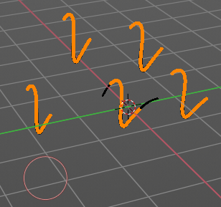
Clone
Clones strokes. You first need to copy a stroke before you can clone it.
Currently you need to be in one of the mask selection modes for that. Then select a stroke. With circle select for example. Copy it with ctrl c. And then you should be able to clone the current stroke around with a mouse click.
Note that it clones the whole stroke, and not just the selected stroke geometry. The clone brush is more of a copy and paste stroke tool.

